Lake Albert Golf Club
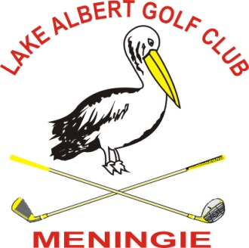
Meningie


18 Hole Ambrose entry form
Group 4 and all clubs welcome
Sunday 12th February 2023

Arrive 9.00am for 10.00am Hit Off (Shot Gun)

ENTRY FEE: $160 PER TEAM OF 4

Includes: BBQ all day

Entry Fee to: LAGC: BSB 085715 A/C 407071951 NAB
First 32 teams paid by 20th January 2023

ENQUIRIES: Trev Rasheed: 0408 824 070 Steve Wake 0428 787 218
Emails: stevenwake49@gmail.com trevrasheed@internode.on.net

Players who do not have current GA Handicap are ineligible to win Major Handicap Trophies
Your contact is: …………………………. Phone: ……………………….

Name/Club | G.A Hcp | Own Cart Y/N
1.
2.
3.
4.
Proudly Sponsored by Drummond Golf Darlington.

